8IM 1 Facial care machine
Use manual
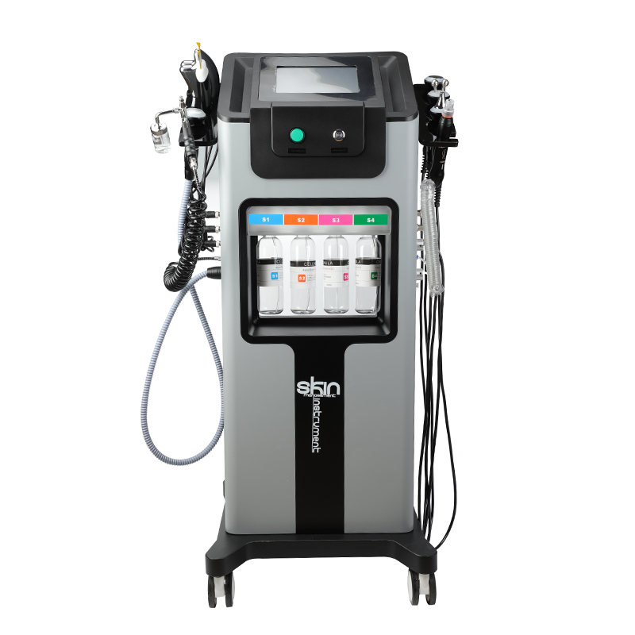

First of all, let us express our gratitude to the customers who have purchased our instruments. This manual is written for customers to use this instrument better. I hope that the company's products and services will bring you respect and courtesy!

1:product description
Black Pearl——The most comprehensive introduction in history
1. Bubble head: vacuum negative pressure, with negative pressure to take away the dirt from the face, clean the face.
2. Shovel skin knife: clean, exfoliate, moisturize the skin.
3. Spray gun: high-pressure oxygen injection to replenish water, deep muscles into the skin layer, easier to absorb through the fine pores.
4. Wave head (face + eyes): Import the product to make the product more absorbed, fine pores, and smooth skin.
5. Eye head: improve the fine lines of the eyes, tighten and lift.
6. Hot and cold head: shrink pores, block nutrition, calm and repair.
7. Girl's line: Gua Sha, detoxification, lifting and firming contours, introduction of essence, shaping and diminishing fine lines
8. Radio frequency head: enhance firmness and promote the re-growth of collagen.

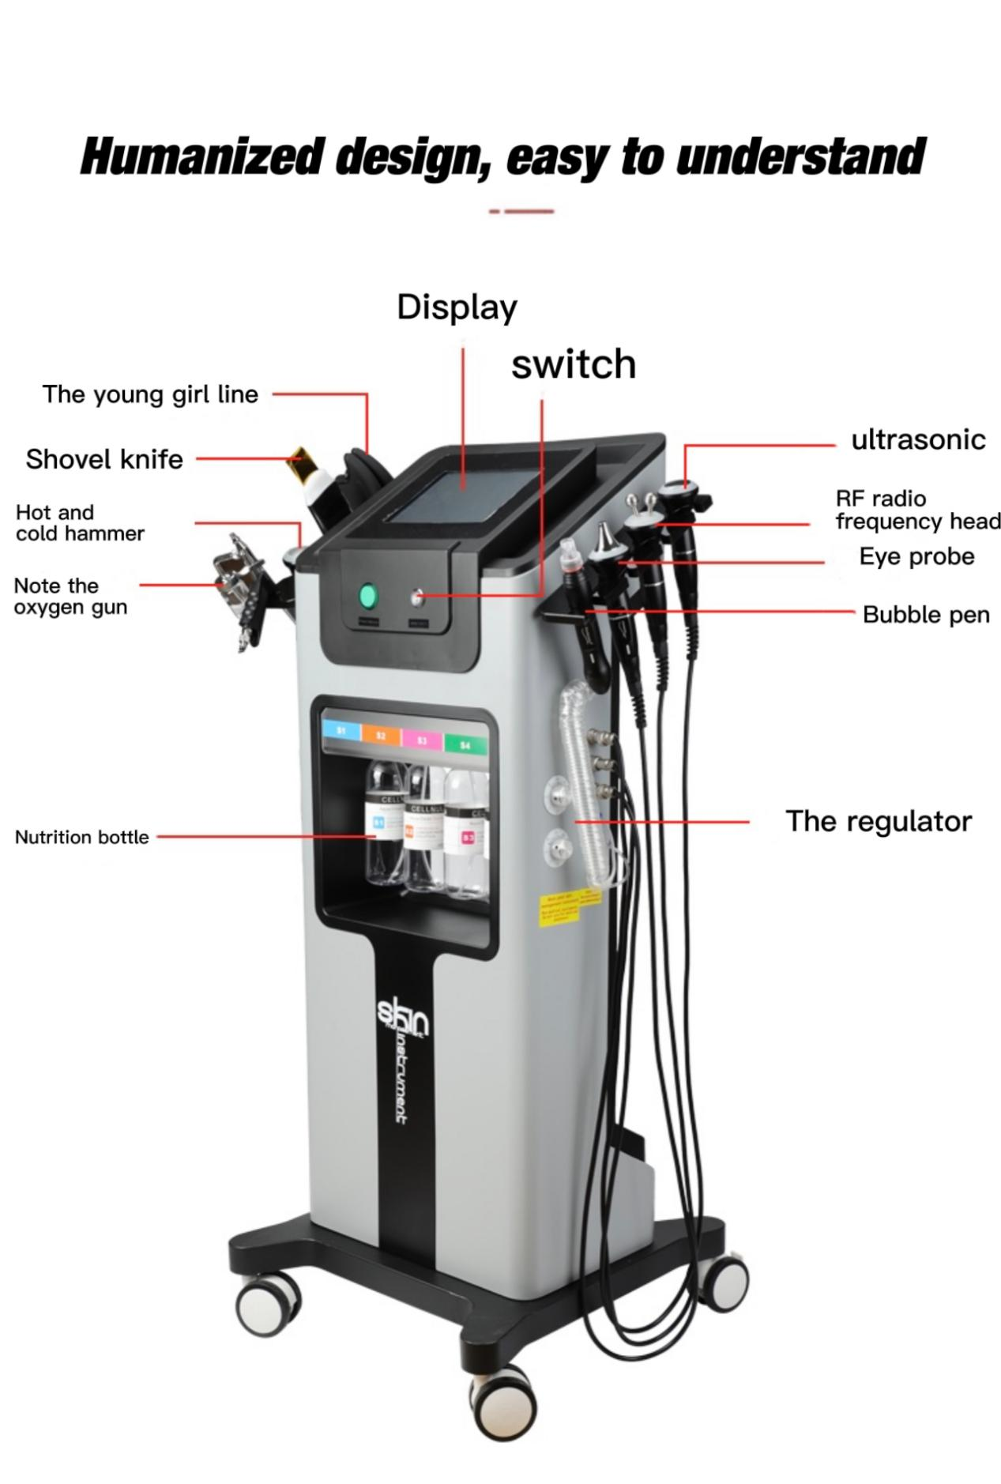
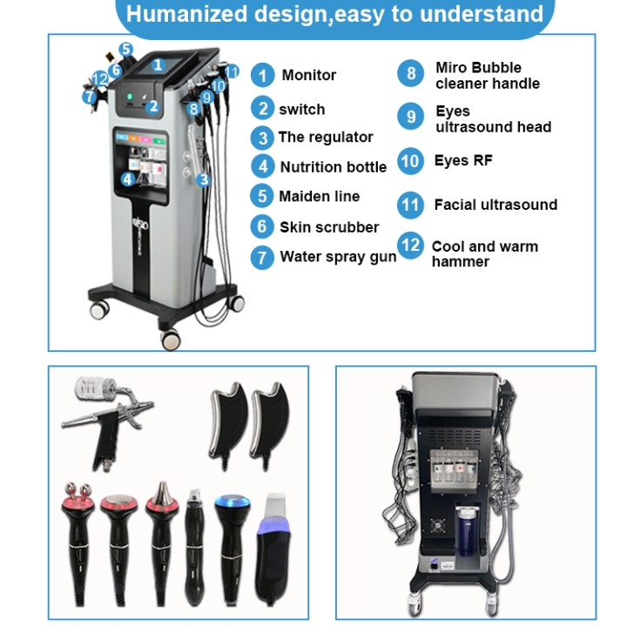

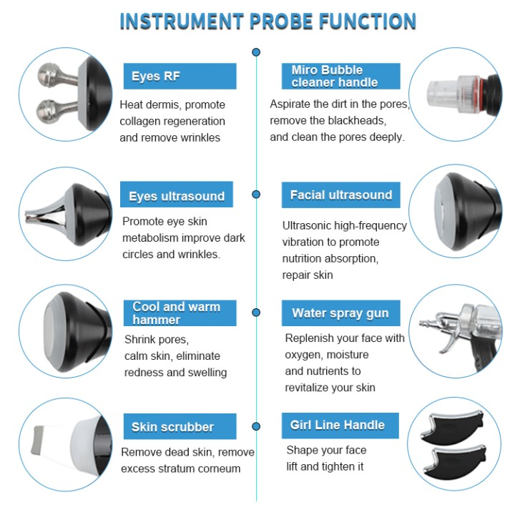
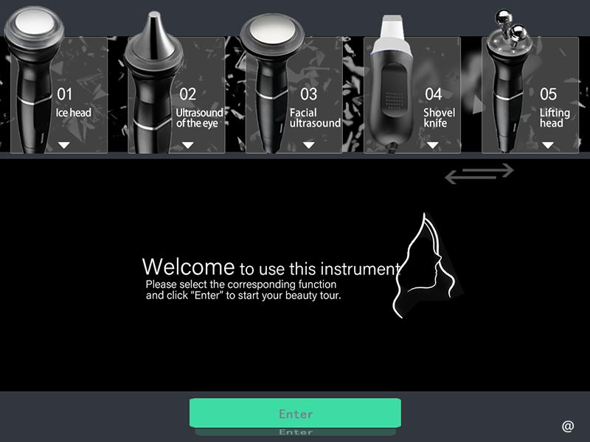
New technology slidabe LCD screen,Touch “ENter”

1:Cool and warm hammer head
The ice treatment allergy,enhance immunity,Skin tightening,shrinks pores,tightens skin,removes wrinkles
Promotes collagen hyperplasia,eliminates radness and sensitivity. Accelerate product absorption.

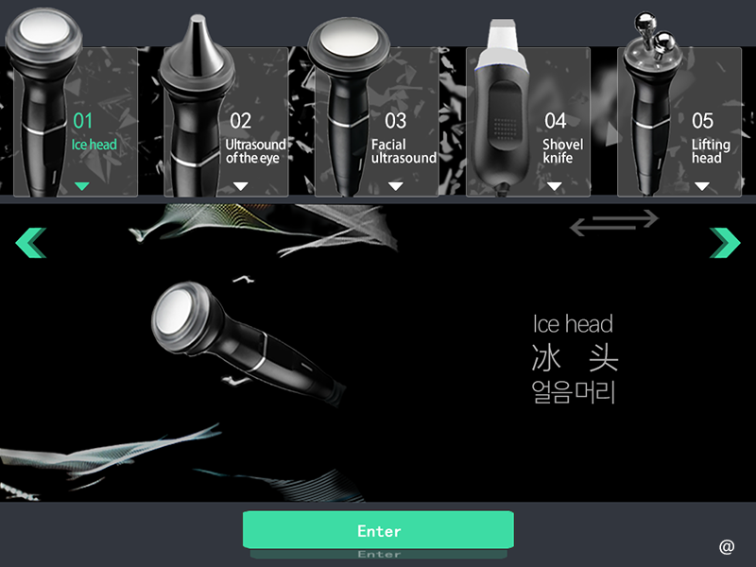

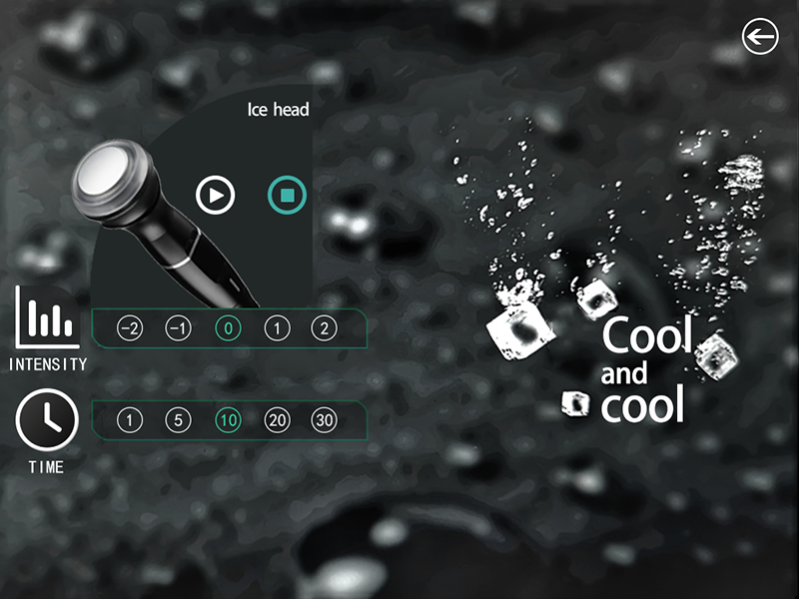
Operation steps for Cool and warm hammer head

Start
Stop

Click this for refrigeration

Click this for heating

This is the time to choose the ice hammer to work
2：RF Lifting head

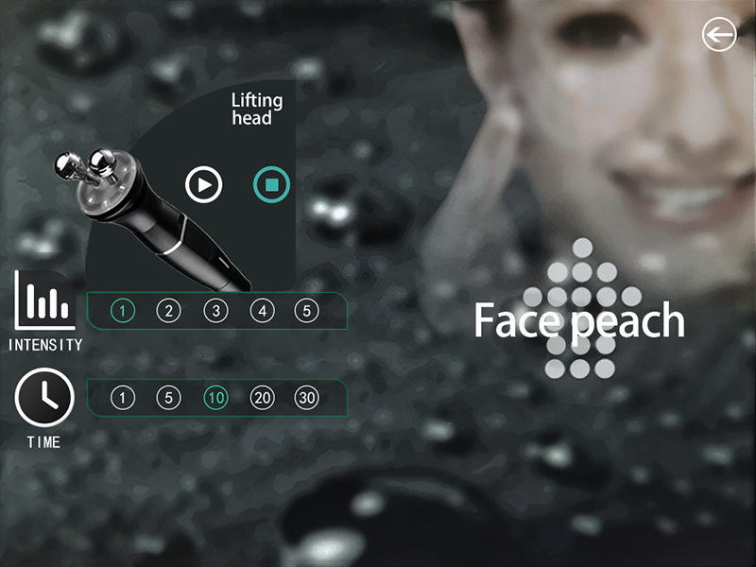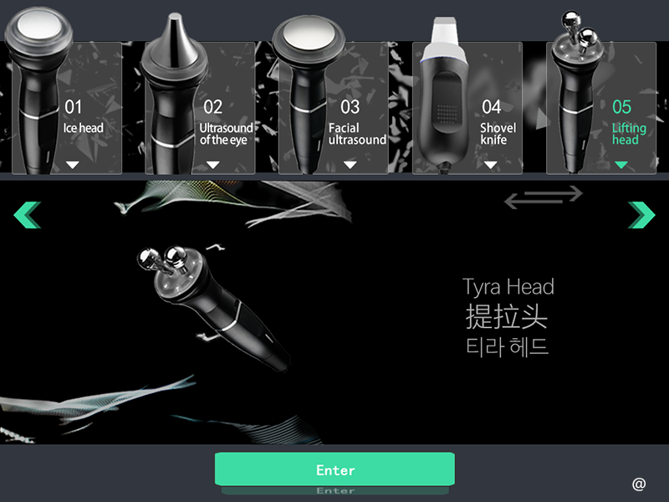

Operation steps for RF lifting head
Start

Stop
This is to choose the strength of RF energy

This is the time to choose the radio frequency controller to work
3：Eyes ultrasound head
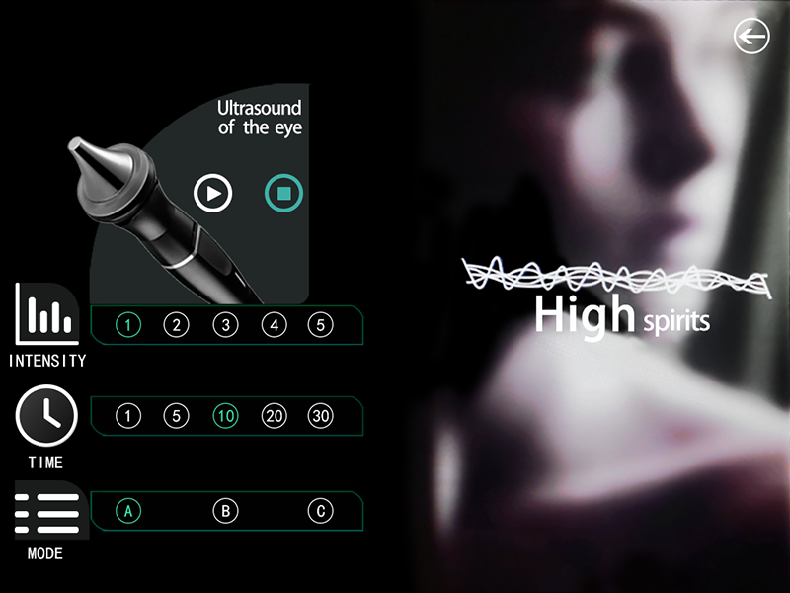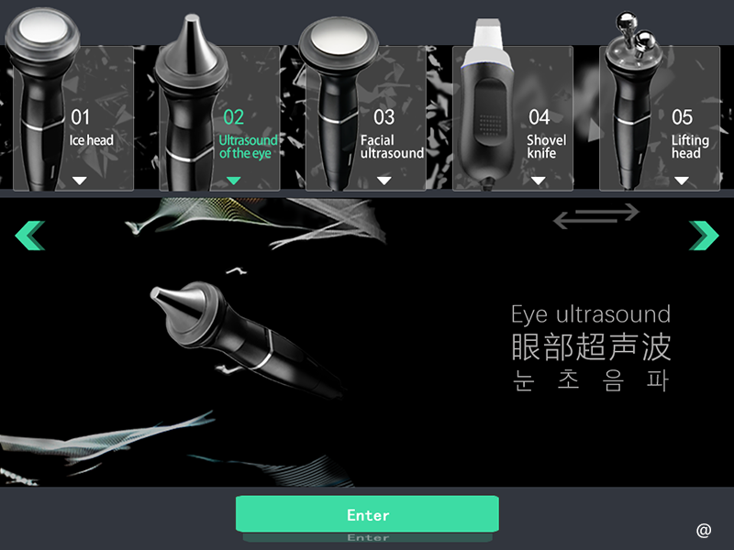
4:Facial ultrasound head

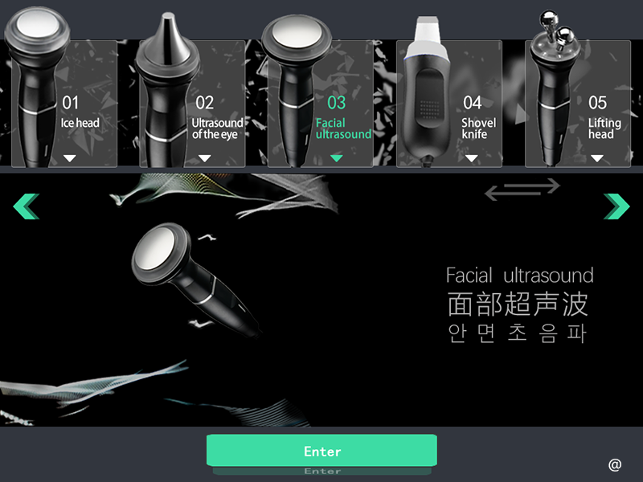

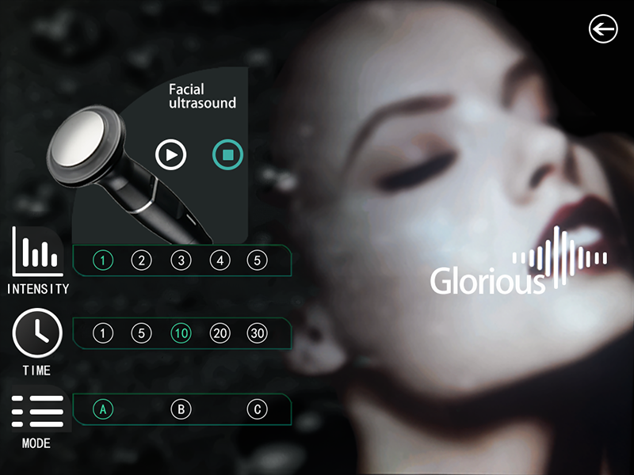
5:Miro Bubble cleaner head

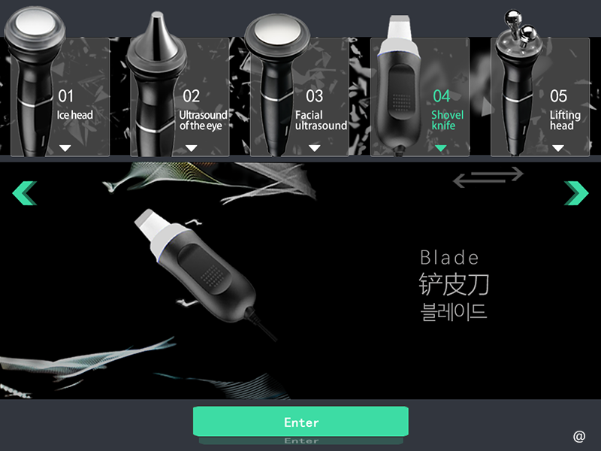

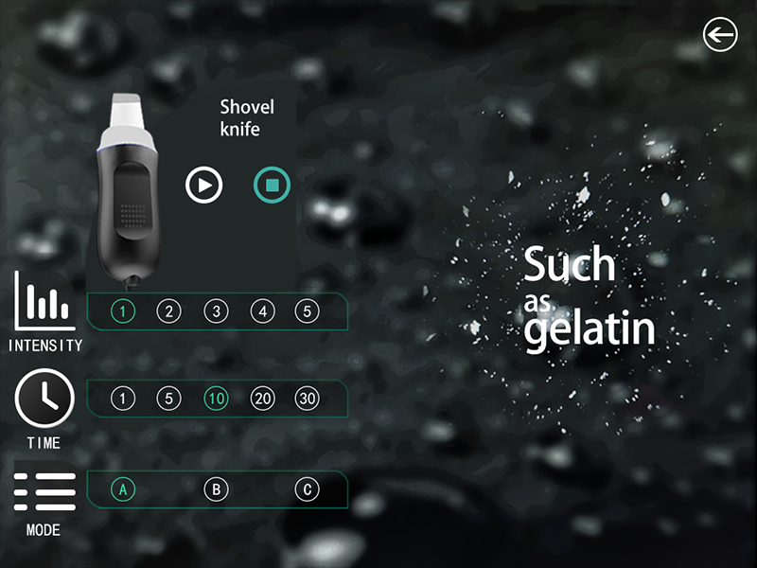
6:Miro Bubble cleaner head

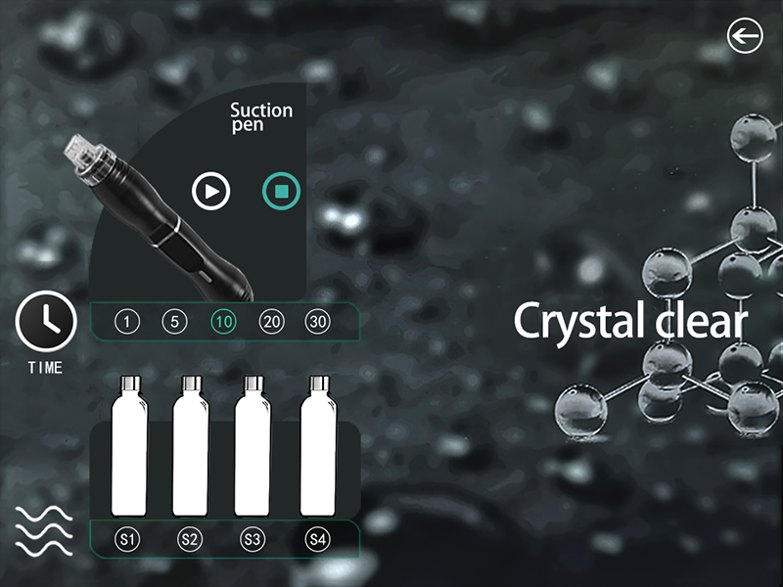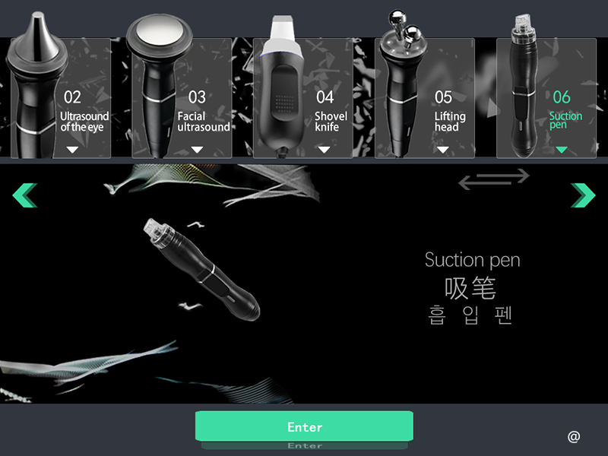
7:Beauty head(lifting Head)

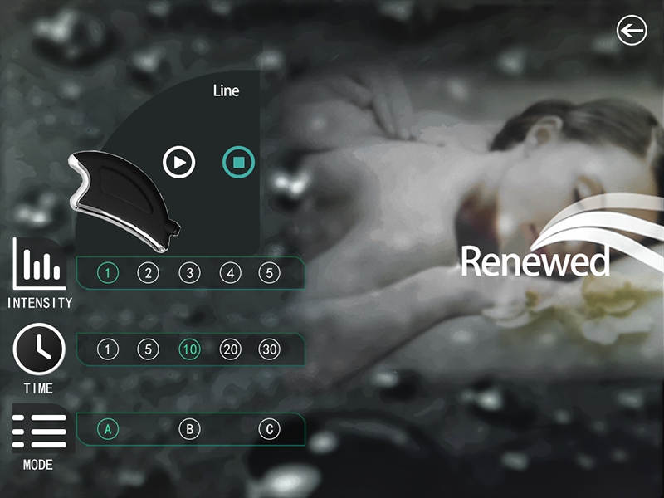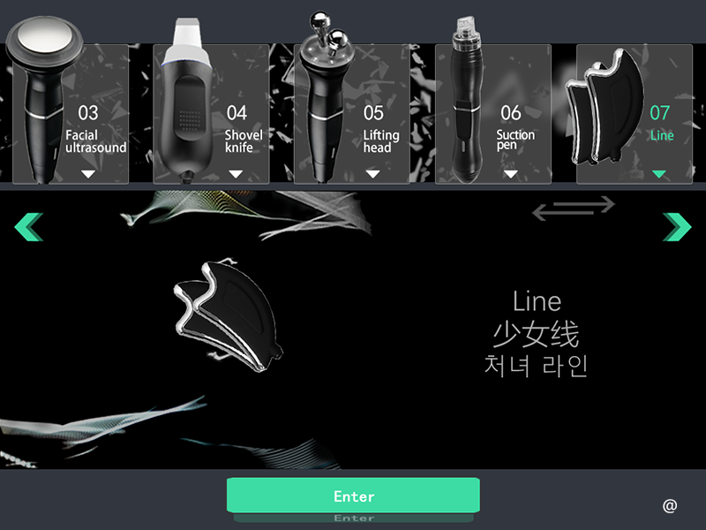
8:Water oxygen head

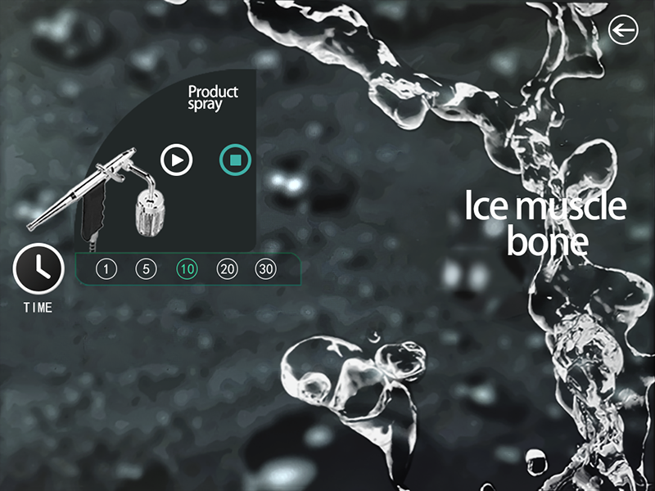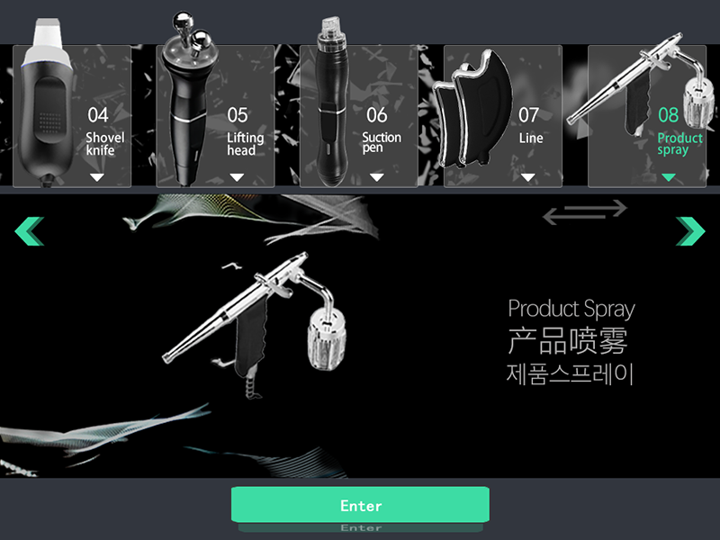
Precautions：
1: Before use, please fill the solution bottle with proper purified water or nutrient solution, and do not use tap water:
2: Pay attention to the liquid level of the waste bottle, please discard it in time to prevent damage to the instrument.
3: Use with caution if the skin stratum corneum is thin or the cheekbones are severely red.
4: People who have undergone facial surgery or deep exfoliation, but have not yet reached the recovery period, use it with caution.
5: After the operation, it is necessary to strengthen the hydration, and apply the hydrating mask continuously for a week. Do not use functional hydrating products.

unsuitable people
1. People with pacemakers or other similar electronic devices implanted in their bodies.
2. Pregnant women.
3. People who have taken oral isotretinoin therapy in the past 9 months (Accutane / Roaccutane / Oratane).
4. There are fillers inside. If gold wires are implanted on the face, it is not recommended.
5. Patients with severe heart disease, diabetes, and hyperthyroidism.
6. The surgical wound has not healed.
7. Patients with advanced tumors.
8. Women with intrauterine contraceptive devices.
9, do not do during menstrual period

Maintenance and repair
Managers must inspect the instruments and components.
1. Whether the power socket is reliably connected to the ground, if not, please replace the power socket.

2. Whether the power cord is deformed, broken, or disconnected: through visual inspection, whether the cord is deteriorated or deformed, if any, it may leak electricity and cause a fire. Please replace with a new power cord immediately.
3. Whether the control handle is abnormal or disconnected: Check whether the output is deteriorated or deformed by visual inspection. If there is any, please replace it when it is produced.
4. Please check whether the content of the prompt before using the instrument is correct. If it is not correct, please stop using it.

5. When cleaning the instrument, the dust must be wiped with a dry soft cloth, and the dirt must be wiped with a soft damp cloth. Before cleaning the instrument, you must turn off the power switch and disconnect the power cord.

6. When using for a long time (more than one year) to clean the dust inside the instrument, it should be done by professional maintenance personnel.
When the instrument is not in use, it should be placed in a ventilated and dry place, and the top of the instrument should be covered with a dust cover.

